Business Case — ExportBrain Trade Intelligence Platform
A Centralized, Secure AI Trade-Intelligence Layer for Egypt’s Export Initiative
Prepared for: Ministry of Investment and Foreign Trade (MFIT) · In connection with: مبادرة مصر تنطلق بالتصدير (Egypt Exports Forward) and بوابة معلومات التجارة الخارجية المصرية · Prepared by: Corbia Innovation Hub · Version 1.1 (Draft for Discussion) — August 2026

1. Document Control
Field | Value
Document Title | Business Case — ExportBrain Trade Intelligence Platform
Prepared For | Ministry of Investment and Foreign Trade (MFIT)
Prepared By | Corbia Innovation Hub — Sadra Abdullah, Director
Companion Document | PRD — ExportBrain Trade Intelligence Platform (v1.0)
Status | Draft — For Discussion
Version | 1.1
Date | August 2026
Annex | A — Product Narrative (includes Architecture Recommendation image)

2. Executive Summary
Under presidential directives to raise Egyptian exports, and under the patronage of the Prime Minister, MFIT has launched مبادرة مصر تنطلق بالتصدير — coordinating Export Development Authority, Export Development Fund, Exhibitions Authority and Commercial Representation so companies can produce and then export. In parallel, MFIT and IDSC launched بوابة معلومات التجارة الخارجية المصرية: 6,650 HS lines, ~50 million records, OECD/UNCTAD/ITC/Atlas and GOEIC data, NTMs, rules of origin, shipping costs, agreements, and dashboards across 15 sectors.
Data and agency coordination now exist. What does not yet scale is on-demand, cited decision support for ministry analysts, affiliated entities and thousands of private exporters. This Business Case proposes ExportBrain: a centralized cited AI intelligence hub on Egypt-resident GPU infrastructure that grounds every answer in the portal and governed agency catalogues, with isolated private workspaces per company.
Full functional detail is in the companion PRD. Phase 4 Future Work lists sixteen AI expansion fields in six categories, informed by peers such as Turkey Easy Export, Germany GTAI AI Search / Förderlotse, UK DBT funding AI summariser, World Bank WITS@AI and Taiwan AiEZ TRADE.

3. Strategic Alignment
ExportBrain sits at the intersection of four national priorities:
• Presidential and Cabinet commitment to raise export volumes and build an export culture of quality, market access and promotion.
• MFIT’s Export Initiative as the service spine across affiliated bodies and governorates.
• The Foreign Trade Information Portal as the digitization nucleus of Egypt’s trade system (IDSC + MFIT).
• Private-sector enablement — manufacturers, exporters, investors and researchers — with sovereign data control.

4. The Opportunity
Today, officials and firms must interpret 6,650 HS codes, multi-source global demand maps, NTMs, origin rules, shipping and agreements, while also navigating which MFIT entity unlocks exhibitions, incentives or commercial desks. Classroom briefings and static dashboards do not close that gap at national scale.
An AI reference layer, grounded strictly in MFIT-approved sources, gives every authorised user an on-demand, cited answer — and gives the Ministry anonymized visibility into where knowledge gaps persist across sectors and governorates.

5. Value Proposition
Benefit | Description
Speed | Trade and service questions answered in seconds from governed sources.
Consistency | One MFIT-approved interpretation of portal facts and agency mandates.
Personalization | Answers reflect each company’s products and certificates without exposing them to peers.
Reduced workload | Entity helpdesks and ministry analysts freed from repetitive routing queries.
Ministry visibility | Aggregated, anonymized reporting on hot topics and sector gaps.
Scalable model | Reusable hub for governorates, future sectors and investment–export linkage.

6. Architecture Options and Recommendation

Option A — Centralized Hub (Recommended for Phase 1)
One MFIT-governed AI intelligence platform serving ministry roles, affiliated entities and private exporters from a shared curated knowledge base, with an isolated private workspace per company or entity team.
• Lowest cost and fastest time-to-value; single knowledge base as portal and catalogues evolve.
• Single point of security governance and audit for MFIT.
• Consistent answers by design across audiences.

Option B — Per-Entity Dedicated Instances
Separate fully isolated instances per major entity or large exporter cohort — highest isolation, materially higher cost; defer unless Phase 1 security review requires it.

Sovereign infrastructure
Dedicated GPU inference and vector storage with data residency in Egypt; no open-internet grounding; full audit of queries and answers.

7. Indicative Cost & Infra Framework
Indicative phase bands only — not a firm quotation. Discovery workshop converts this into a statement of work covering GPU hosting, knowledge operations, bilingual UX and entity onboarding.
Phase | Focus | Indicative band
0 Discovery | Security, portal access, pilot entities | Workshop + fixed discovery fee
1 Pilot Build | Central hub + shared KB + 1–2 entities + exporter cohort | Build + monthly infra
2 Pilot Eval | Metrics, hardening, content refresh | Ops + support
3 Multi-entity | Remaining affiliated bodies + broader private access | Roll-out + capacity
4 Scale + Future | Governorates + Future Modules catalogue | Ongoing + module SOWs

8. Roadmap
• Phase 0 — Discovery (2 weeks): hosting model, security, portal/IDSC access path, pilot selection.
• Phase 1 — Pilot Build (4 weeks): centralized hub + shared KB + private workspaces.
• Phase 2 — Pilot Evaluation (3 weeks): run against success metrics with selected entities and exporters.
• Phase 3 — Multi-entity roll-out (4 weeks): onboard remaining Export Initiative bodies.
• Phase 4 — Scale & Future Work (ongoing): governorates, sectors, and the Future Modules catalogue below.

8b. Future Work — AI AI expansion fields (by category)
All modules below are post-pilot. They activate only after governed source ingestion, data-processing agreements and MFIT steering approval. HS, remedies and buyer modules remain advisory and do not replace licensed brokers or official filings.

Category A — Market Discovery & Opportunity
• F1 Smart market / “where to export” advisor (peer: Turkey Easy Export).
• F10 Buyer / partner discovery briefs — gated until data rights cleared (peer: AiEZ / trade-intel vendors).

Category B — Market Access & Compliance
• F4 NTM / SPS / standards navigator.
• F5 FTA / rules-of-origin coach.
• F6 HS classification assistant (advisory only).
• F15 Trade remedies / safeguard watch (official feeds only).

Category C — Agency Services & Export Enablement
• F2 Export incentives & funding matcher (peer: UK DBT AI summariser; German Förderlotse).
• F3 Agency / service router across EDA, Fund, Exhibitions, Trade Rep, GOEIC.
• F8 Exhibition & mission matcher.
• F9 Commercial Representation brief.

Category D — Operations & Documentation
• F7 Trade data / methodology tutor (peer: World Bank WITS@AI).
• F11 Logistics & shipping cost explainer.
• F12 Document pack / checklist generator (not auto-customs filing).

Category E — Ministry Insight & National Scale
• F13 Governorate exporter onboarding coach.
• F14 Ministry anonymized insight layer.

Category F — Investment–Export Linkage
• F16 Investment–export linkage advisor — fits MFIT dual mandate.

9. Governance & Partnership
• MFIT steers content policy and audience access; IDSC/portal remain authoritative for trade statistics.
• Each affiliated entity owns its service catalogue; companies own private uploads.
• Corbia Innovation Hub acts as technology delivery and hosting partner under a formal DPA.
• Joint steering group (MFIT, selected entities, Corbia) oversees pilot and scaling.

10. Risks
• Source freshness if portal/agency feeds lag.
• Hallucination — mitigated by mandatory citations and decline-when-unsure.
• Cross-tenant leakage — mitigated by workspace isolation and audit.
• Portal API / data-sharing agreements delayed.
• Communications sensitivity on national initiative branding.

11. Return / Success
Pilot metric | Target
Faster time-to-insight vs manual search | ≥60%
Answers with valid citation | ≥95%
Monthly active authorised users (pilot cohort) | ≥80%
Cross-tenant data incidents | 0
Agency routing ticket deflection | Measurable drop vs baseline

12. Next Steps
• Approve a Phase 0 discovery workshop between Corbia Innovation Hub and MFIT IT/security, portal/IDSC and 1–2 entity champions.
• Confirm data-access path to portal corpora and agency service catalogues.
• Convert this framework into a firm quotation and statement of work.
About Hossam Zein / Corbia Innovation Hub
mail: hossamzein@engineer.com · +20 111 822 5899 · linkedin.com/in/hossamzein

Annex A — Product Narrative
This annex tells the ExportBrain product story for ministry leadership: why the intelligence layer matters now, how it sits on the Export Initiative and Foreign Trade Information Portal, and why Option A (Centralized Hub) on sovereign Egyptian infrastructure is the recommended architecture.

A.1 The national moment
Egypt has launched مبادرة مصر تنطلق بالتصدير under presidential export targets and Prime Minister patronage. Affiliated bodies — Export Development Authority, Export Development Fund, Exhibitions Authority and Commercial Representation — are aligned so firms can produce and then export, expanding the exporter base across governorates. In parallel, MFIT and IDSC opened بوابة معلومات التجارة الخارجية المصرية: 6,650 HS lines, ~50 million records, OECD/UNCTAD/ITC/Atlas and GOEIC data, NTMs, rules of origin, shipping costs, agreements, and dashboards across 15 sectors. The digitization nucleus exists. What leadership still needs is an on-demand, cited decision layer that ministry analysts, entity officers and exporters can trust at national scale.

A.2 The product in one sentence
ExportBrain is a bilingual (AR/EN) cited AI trade advisor: a single MFIT-governed hub that retrieves only from the portal and approved agency catalogues, isolates each company’s private workspace, and answers with mandatory citations — hosted on Egypt-resident GPU infrastructure.

A.3 Who it serves (ministry-first)
• Ministry leadership — anonymized insight into where exporters and entities struggle (sectors, NTMs, routes, service gaps).
• Ministry analysts — faster, consistent interpretation of portal facts without replacing official dashboards.
• Affiliated entities — service routing and catalogue Q&A that deflects repetitive helpdesk load.
• Private exporters — market, access and agency guidance grounded in governed sources, with private product/certificate context.

A.4 How the experience works
• Ask in Arabic or English → retrieve from curated knowledge → ground against tenant workspace when relevant → return a cited answer or decline when sources are insufficient.
• v1 seeds market briefs, NTM/origin guidance, agency routing, private uploads, RBAC, audit and anonymized ministry analytics — without claiming Future Modules as live scope.
• Pitch and pilot stay scripted/governed; production RAG and GPU capacity are delivered under formal SoW after discovery.

A.5 Architecture recommendation (mandatory image)
Option A — Centralized Hub is recommended for Phase 1: one MFIT-governed platform, shared curated knowledge base, per-tenant private workspaces, single security and audit plane, and Egypt-resident GPU + vector store + audit logging. Option B (per-entity dedicated instances) is deferred unless Phase 1 security review requires higher isolation at higher cost. Sovereign infrastructure is mandatory: inference and embeddings stay in Egypt; no open-internet grounding.
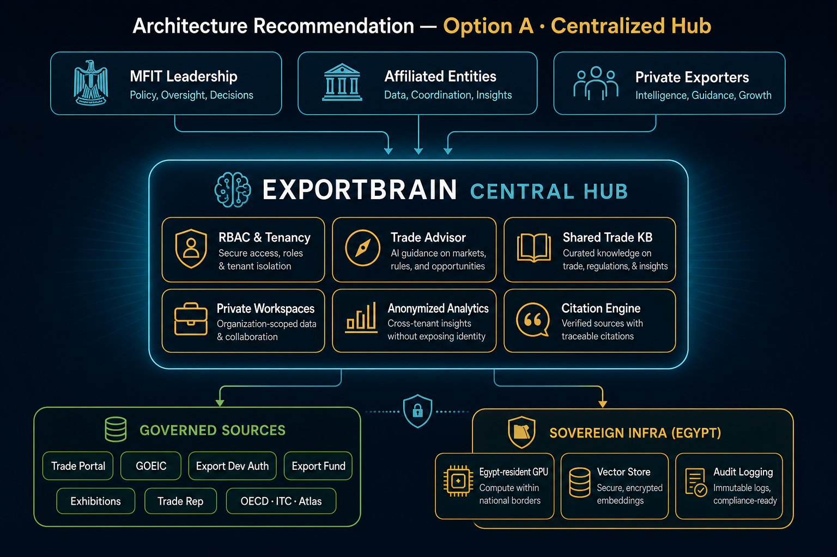
Figure A.1 — Architecture Recommendation: Audiences → ExportBrain Central Hub → Governed Sources + Sovereign Infra (Egypt).
Read the diagram left-to-right and top-to-bottom: audiences connect into the hub; the hub draws only from governed sources; sovereign infra underpins residency, retrieval and audit. This figure is the visual companion to §6 of this Business Case and should be used in leadership briefings.

A.6 Why now
• The Export Initiative and portal create a unique window: services and data are visible; advice is not yet cited at scale.
• Ministry leadership gains a governed AI layer without fragmenting into entity silos.
• Sovereign hosting aligns with national data-control expectations for trade and investment mandates.
• A clear Phase 0–4 roadmap keeps Future Modules (F1–F16) honest — optional after pilot, never claimed as v1 live product.

A.7 Closing ask
Approve a Phase 0 discovery workshop with MFIT IT/security, portal/IDSC and 1–2 entity champions to lock data-access paths, tenancy model and a firm SoW for the centralized sovereign hub.

